

CapSTONE project

PowerBi



February 1, 2024

Submitted TO: Odinschool

Submitted By: Aamir Sitponiya (S6308)

Classic Models

**Data Analysis & Visualization**

**Table Of Contents_ Page No.**

**_____________________________________________________________________________________**

1. Problem Briefing. 2
2. Tour to the Dashboards.

* Sales Dashboard 3
* Orders Dashboard 5
* Customers Dashboard 6
* Employees Dashboard 7
* Forecast 8

1. Data Transformation Steps. 9
2. Insights

* Sales Dashboard 10
* Orders Dashboard 12
* Customers Dashboard 13
* Employees Dashboard 14
* Forecast 15

**­­**

1. **Problem Briefing.**

A small company Axon, which is a retailer selling classic cars, is facing issues in managing and analyzing their sales data. The sales team is struggling to make sense of the data and they do not have a centralized system to manage and analyze the data. The management is unable to get accurate and up-to-date sales reports, which is affecting the decision-making process.

To address this issue, the company has decided to implement a Business Intelligence (BI) tool that can help them manage and analyze their sales data effectively. They have shortlisted Microsoft PowerBI and SQL as the BI tools for this project.

The goal of the capstone project is to design and implement a BI solution using PowerBI and SQL that can help the company manage and analyze their sales data effectively.

So, Here I have been given with the classic models dataset to solve the above problem. By analyzing the dataset, I have designed the different PowerBi dashboards which will help the organization to take some constructive decisions.

**2. Tour to the Dashboards.**

**\* Sales Dashboard \***

-This is the Navigation bar through which you can navigate to different pages.

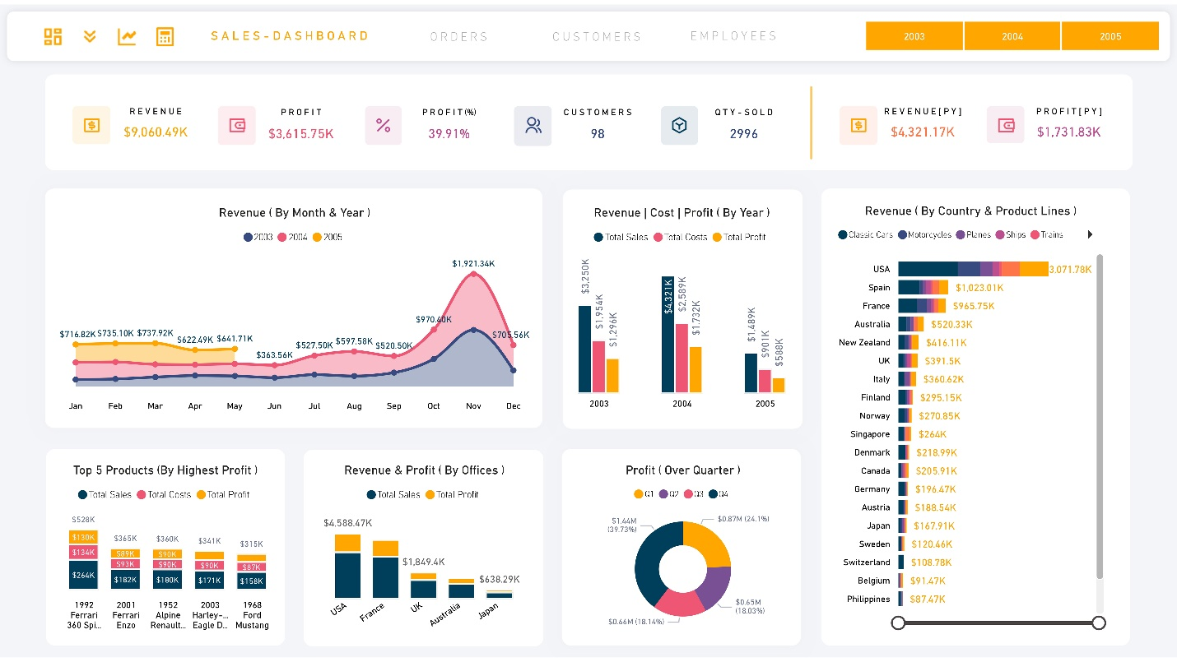

(Future Sales Forecaster) (Different Dashboard Links)



(Opens Slicer) (Calculation) (Year Slicer)

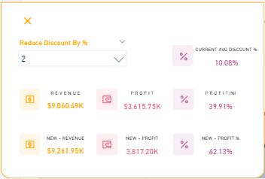

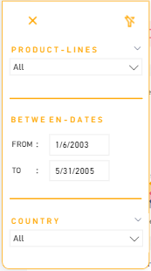

(Calculating Sales | Profit | Profit % if Reduce

The discount rate)

(Slicers For Filtering Data)

(Sales KPI – Key Performance Indicator)

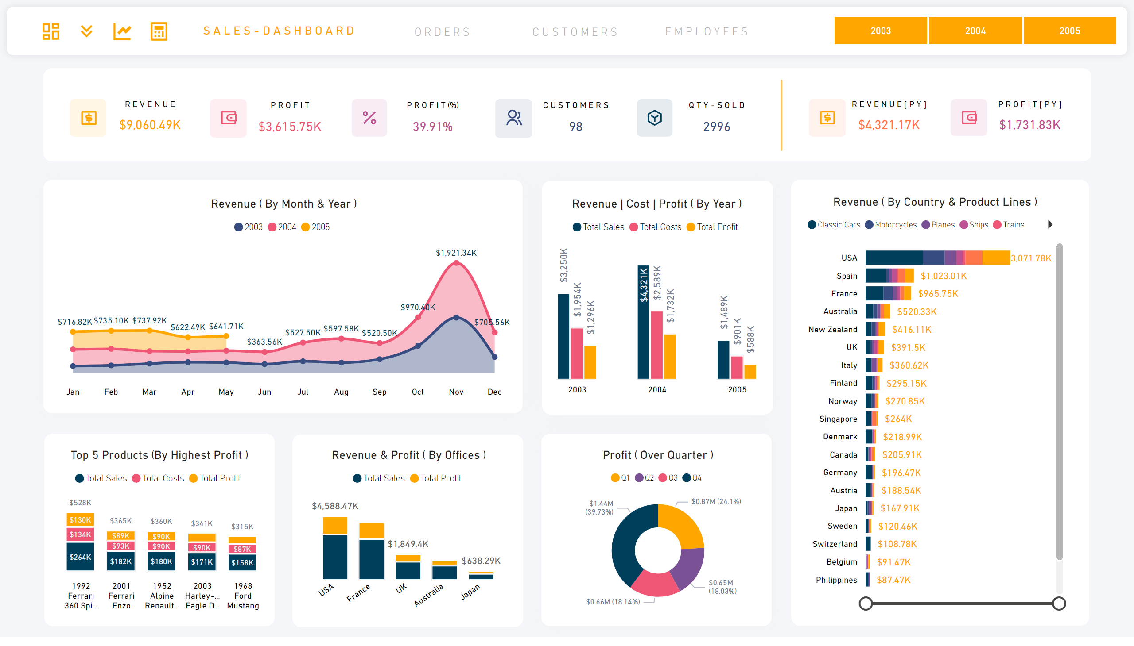

(Total Sales) ( Profit %) (Total Qty Sold) (Previous Year Profit)



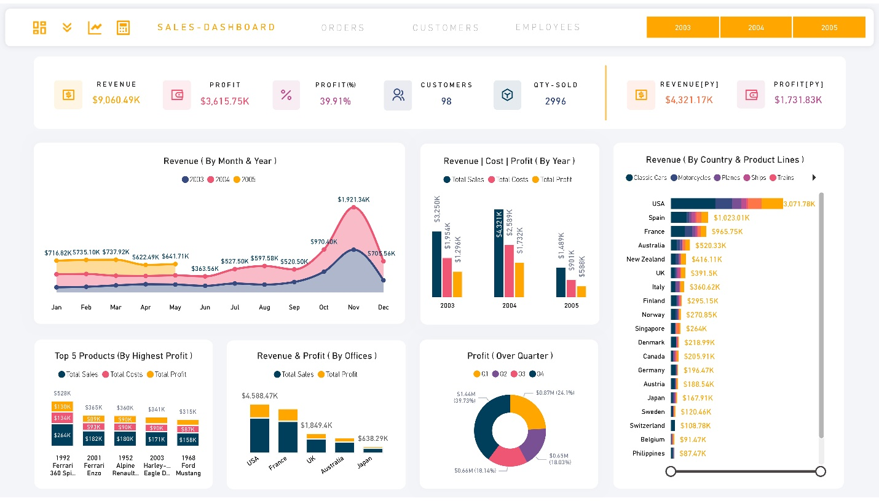(Total Profit) (Tota Customers Ordered) (Previous Year Sales)

( Visualization of Sales Data with Different Charts )

**\* Orders Dashboard \***

( Visualization of Sales Data with Different Charts )

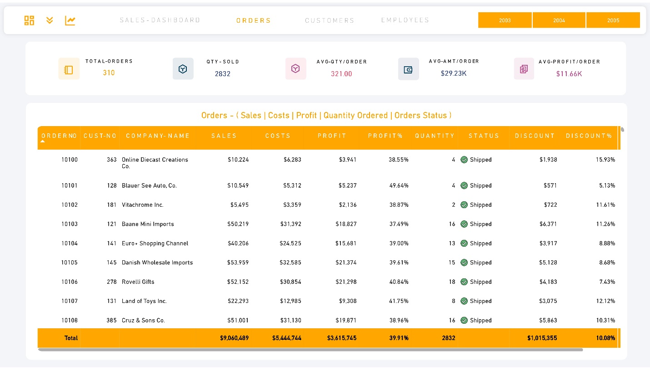(Orders KPI ) (Avg Amount / Order)

(Total Orders) (Total Qty Sold) (Avg-Qty/ Order) (Avg-Profit/ Order)



(Customer Company Wise Orders Tracking)

**\* Customers Dashboard \***

(Total Customers) (Disputed Customers) (Repeated Customers)

(Customers Placed Orders) (Customer Cancelled Orders)

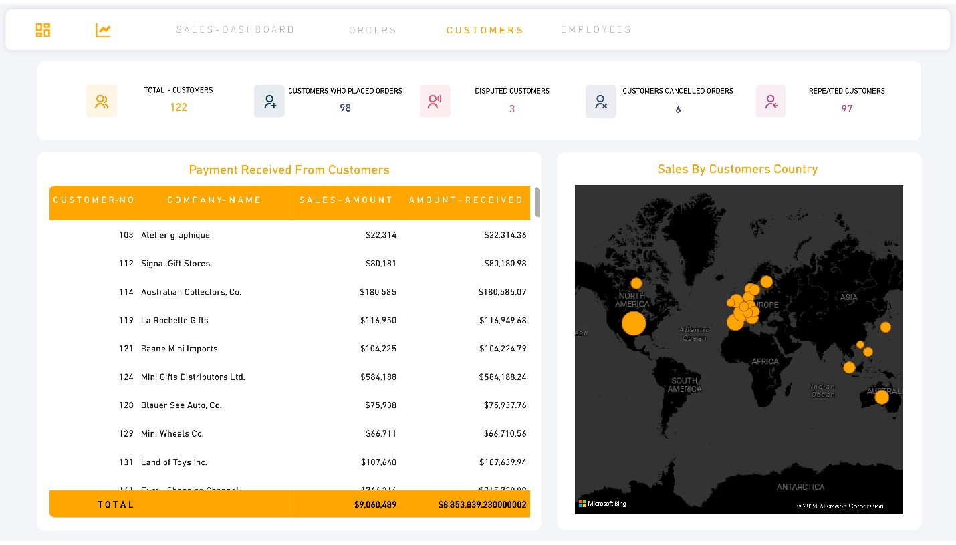

(Customer Wise Total Sold & Payment (Customers Country Wise Sales)

Received)

**\* Employees Dashboard \***

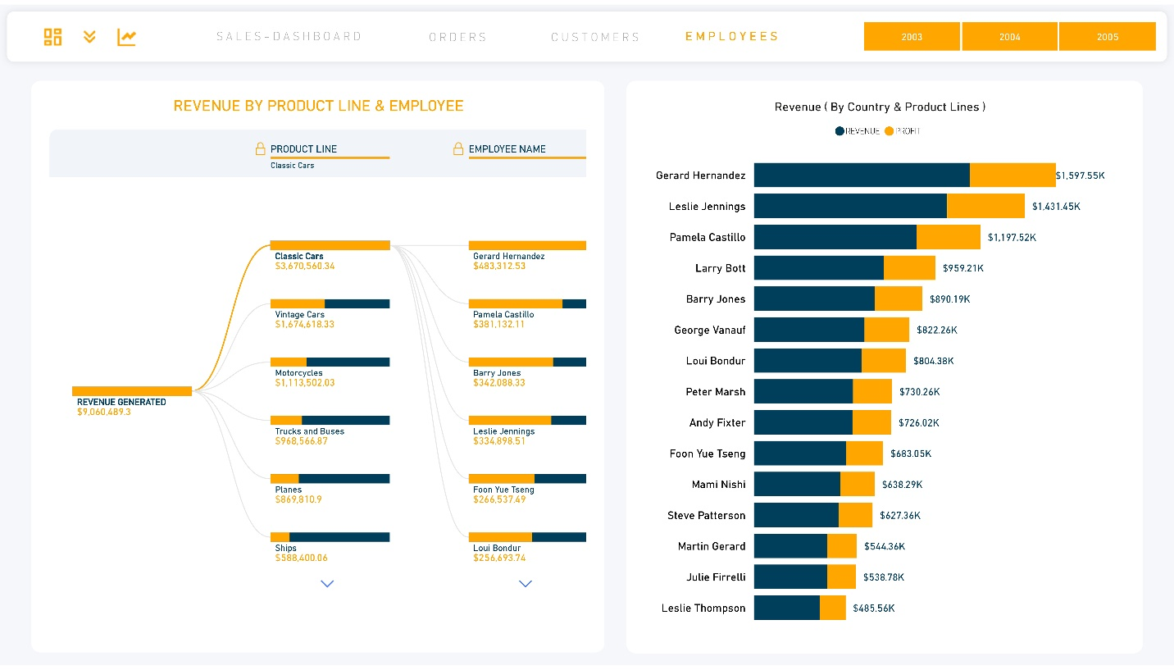

(Product Lines & Employees Wise ( Revenue & Profit By Employees )



Sales)



**\* Forecast Page \***

Forecast for the last running year which is 2005.

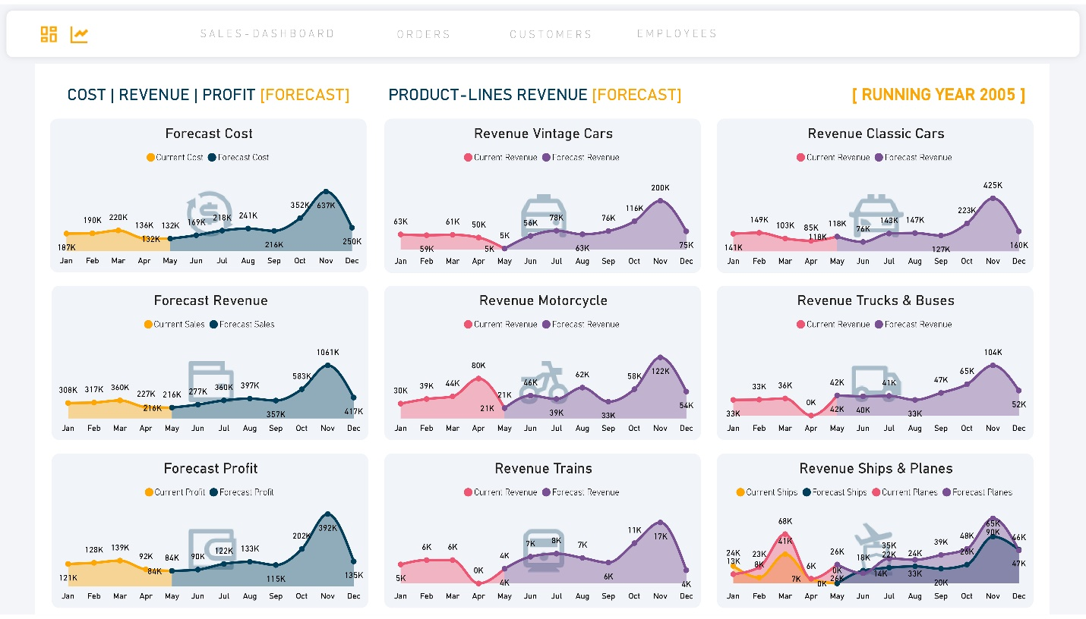

(Forecast Of Cost, Sales & Profit) (Forecast by Sales By Product Lines)

**3. Data Cleaning & Transformation**

1. **Customers Table :**

**addressLine2 :**- Filled NULL values with N/A

**state :** filledNULL values with N/A

**postalCode :** Filled NULL values with N/A.

**SalesRepEmployeeNumber :** Filled NULL with 0.

**SalesRepEmployeeNumber :** Changed datatype from float to whole

number.

1. **Employees Table:**

**officeCode :** changed datatype from text to int.

**reportsTo :** Filled NULL with 0.

**reportsTo:** Changed datatype from float to int.

1. **Office Table:**

**officeCode :** Changed Datatype from string to int

**addressLine2 :** Filled NULL with N/A

**state:** Filled NULL with N/A

**territory:** Filled NULL with N/A

1. **OrderDetals:**

**orderLineNumber :** Changed Datatype to int.

1. **Order Table:**

**comments:** FilledNULL with “NO Comments”

1. **ProductLines Table:**

**htmlDescription:** Removed field as it was unnecessary.

**Image :** Removed field as it was unnecessary.

**4. Insights.**

**\* Sales Dashboard \***

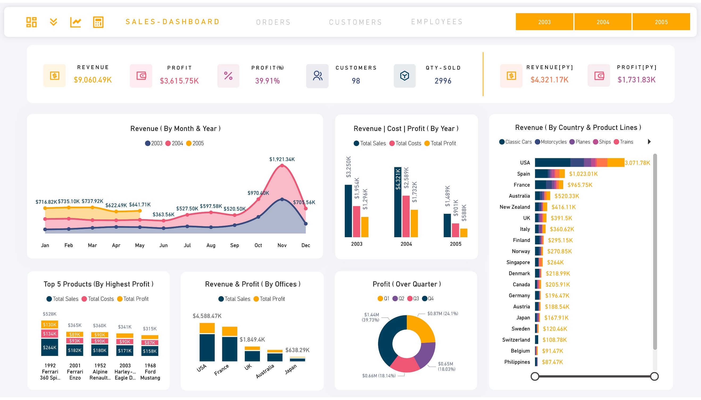

* Above figure gives an idea of revenue by years and months.
* So, if we put an eye on it, we can see that in the year 2004 we are having a highest sale and a November is particular month in which there is a highest sale.
* And as we can see that in the month November each year, we are having a highest sale.
* So, at this point we got an idea that in the month of November there is high demand of our products.

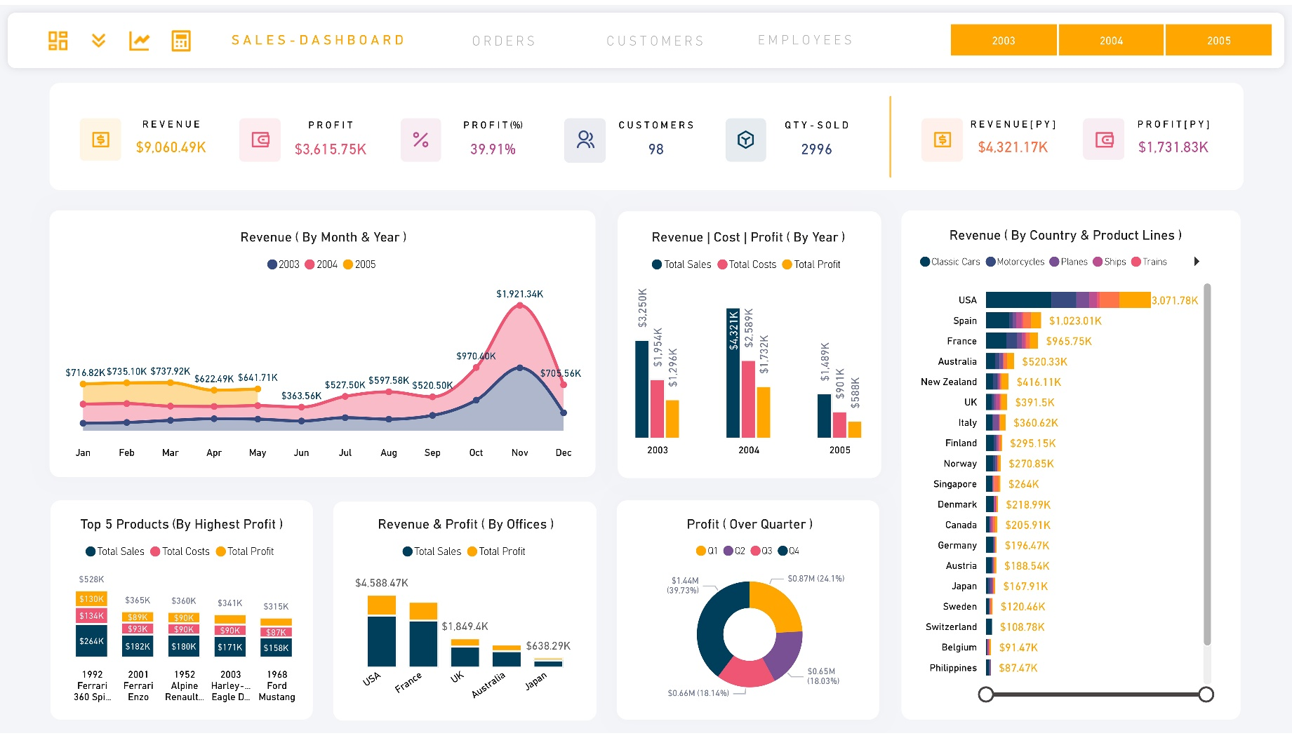

In this figure it shows the revenue, cost and profit by each year.

As said before that in the year 2004 we are having a highest sales and profit too.

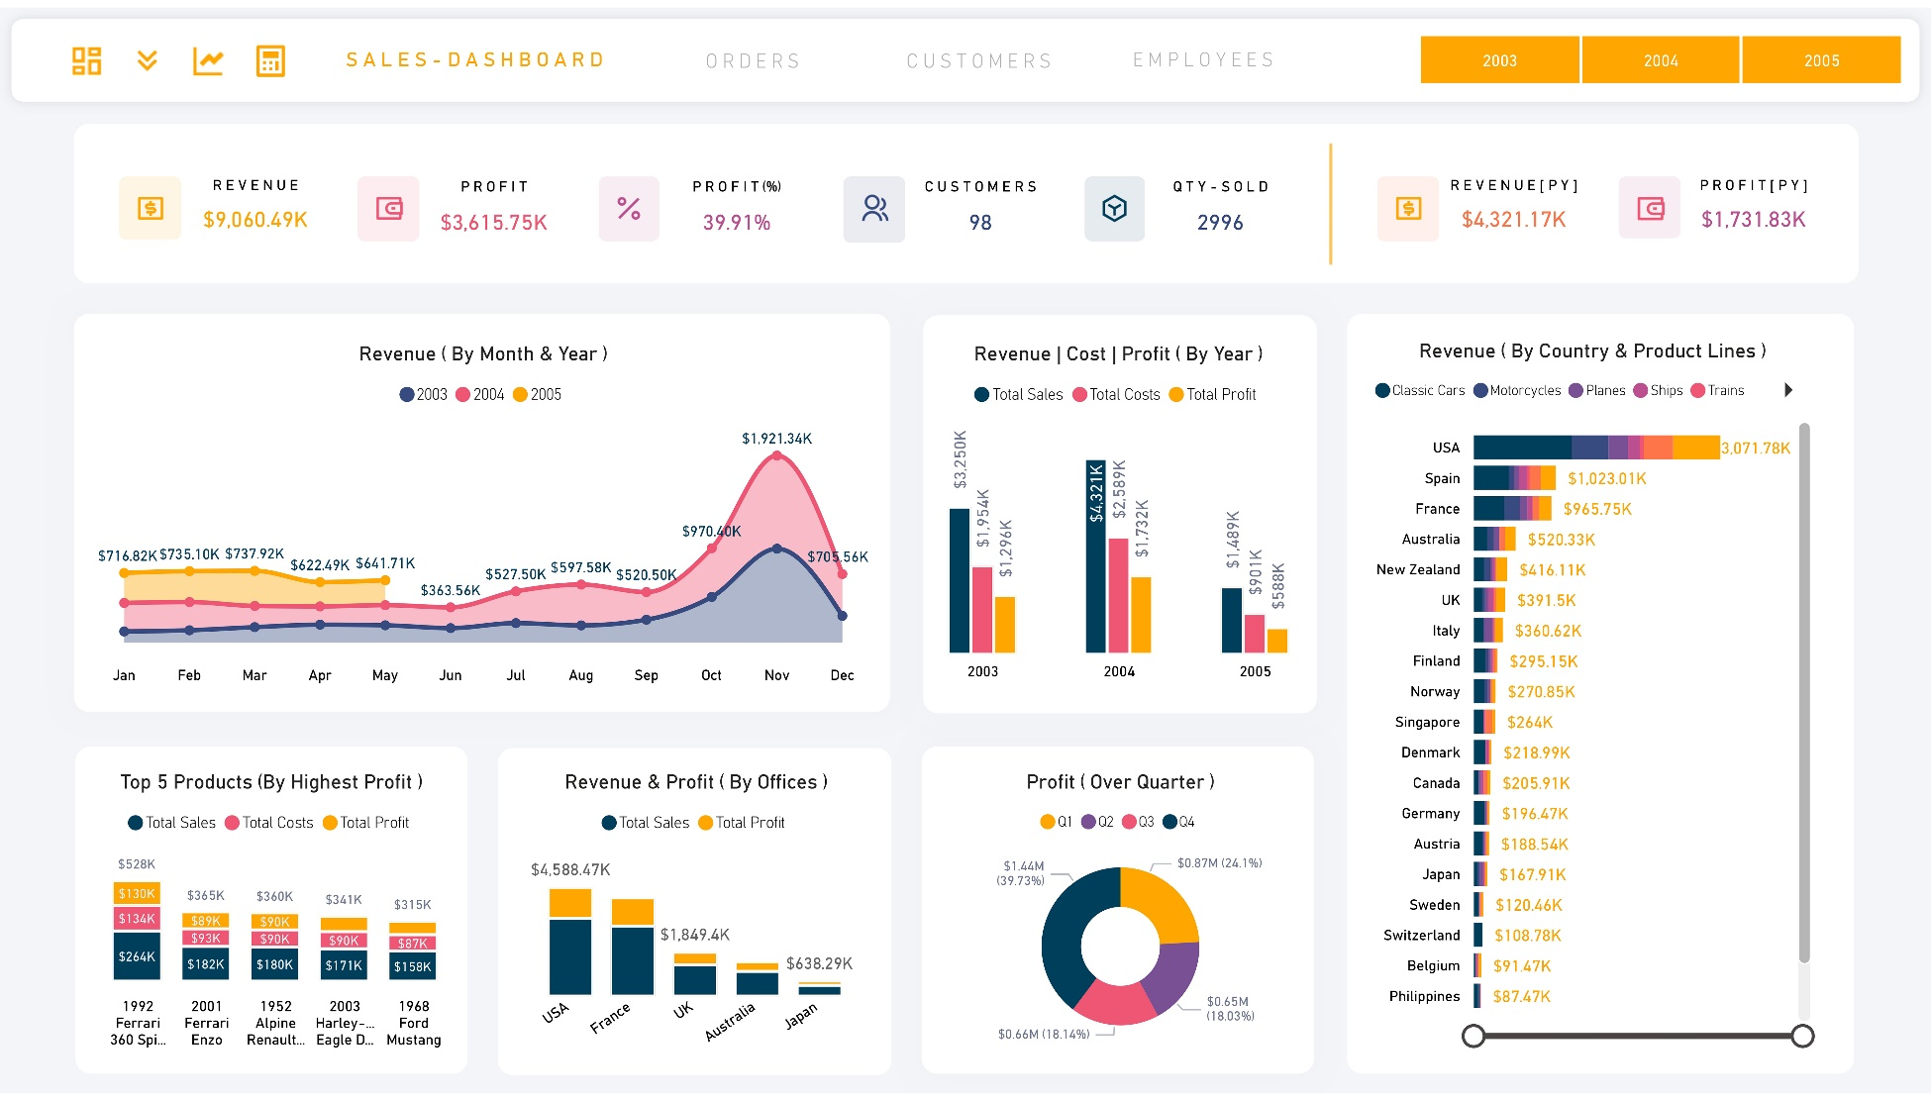

* In this figure it shows the profit over each

Quarter.

* So, in Quarter 4 we are having a highest profit

And in Quarter 2 we are having a least profit.

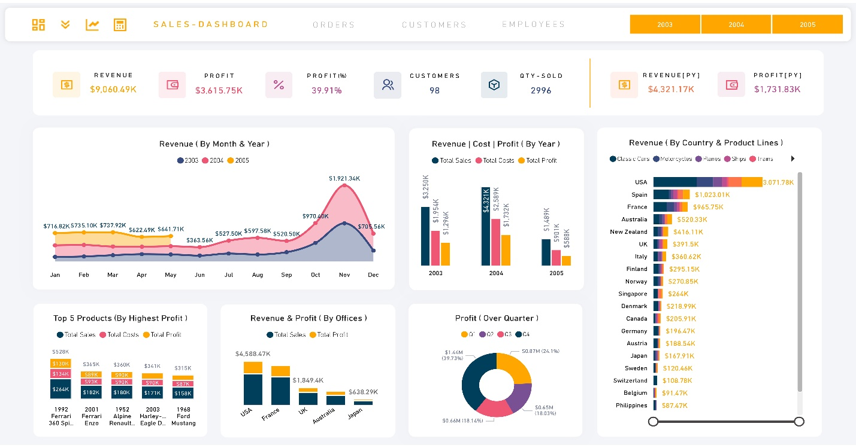In this figure, it shows the sales over different countries and product lines.

So, the highest sale comes from the country is USA.

The least sale comes from the country is Hong Kong.

And the highest selling product Lines products is Classic cars

Least product Lines sales is by the trains product line.

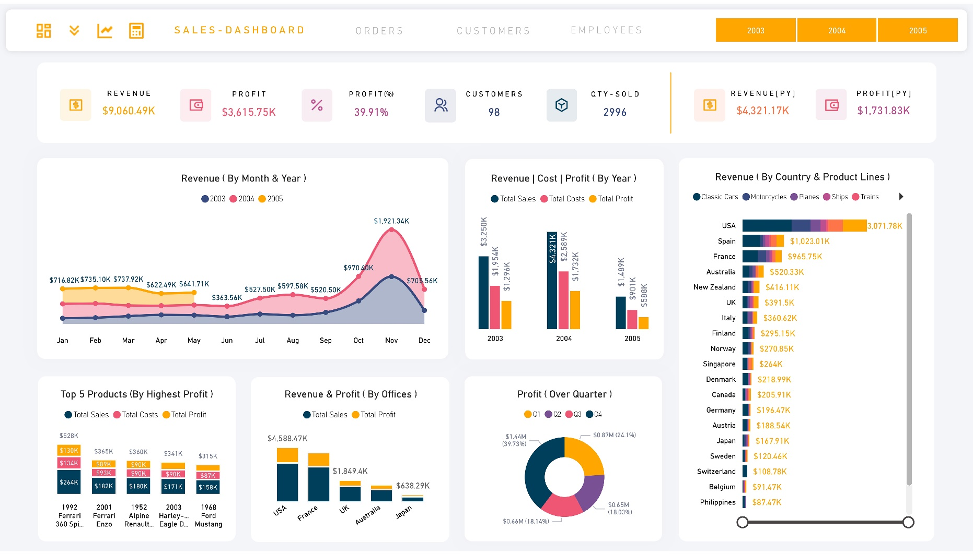

* 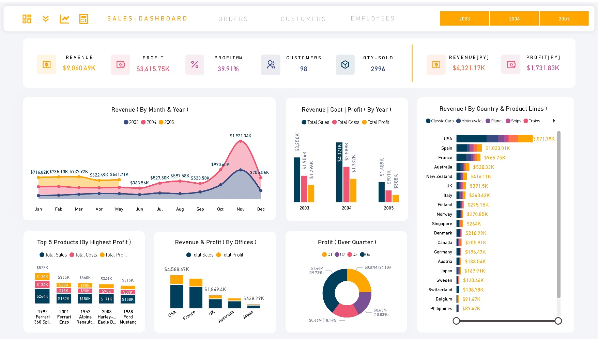In the figure, it shows the sales and profit

Generated by the offices in different countries.

* The office in USA is having a highest sale and

Profit.

* The office in Japan is having a least sale and

Profit.

* In the figure, it shows the information highest

sales, Cost and profit generated by the top 5

products.

**\* Orders Dashboard \***

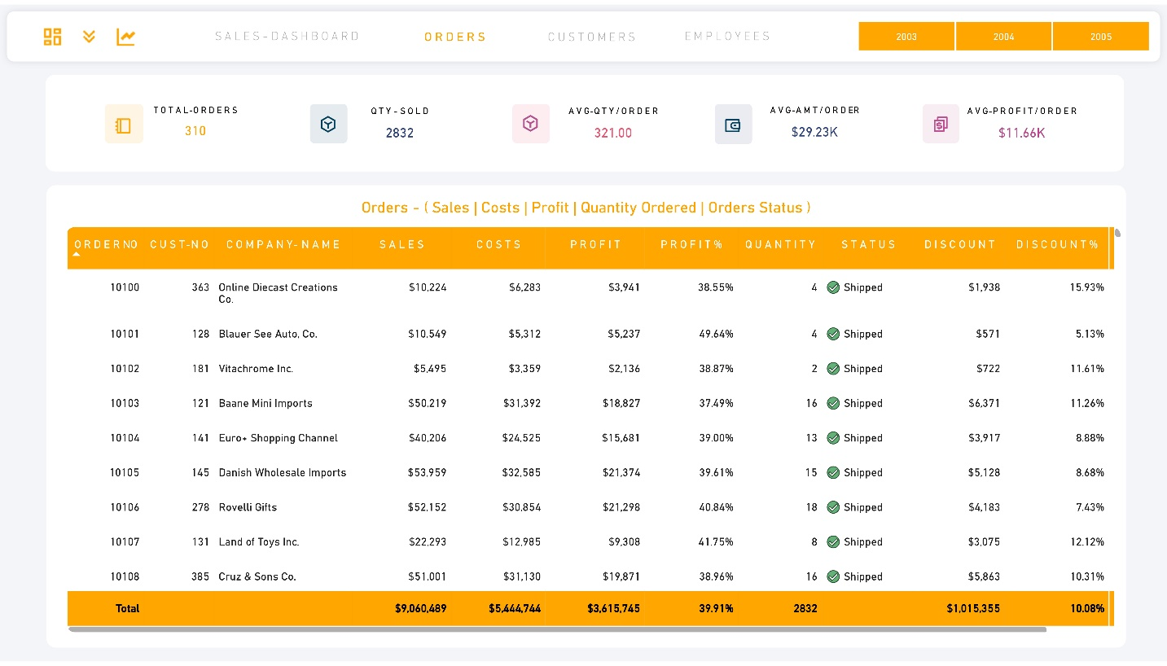

In this dashboard, I have prepared a detailed view of orders, through which user can easily see that what is the sales, costs, profit, profit%, status, discount, discount% by order wise.

Here, one can be taken as an indicator that, if we look at the total discount given up until now is $1015K which is on an average of 10.08%.

By looking at this, I have designed one calculator, where we can simply reduce the discount % and see what was the current revenue, profit and profit% and by reducing discount how much profit, revenue and profit % could be increased.



We can simply click on this icon to open the calculator. It is available on sales and orders dashboards only.

So, if you don’t see it, kindly navigate to orders or sales dashboard.

**\* Customers Dashboard \***

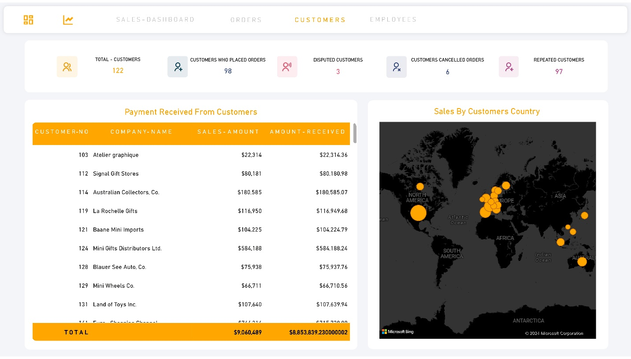

* In this dashboard, very top we have KPI, which shows how many total customers we have and among them how many customers have placed the orders, than how many customers are disputed and who have cancelled the orders.
* And last KPI shows, how many customers are repeated.
* Coming down, on the left hand side we have a report view which shows the customers wise sales amount and how much we have received from them.
* Through that we can identify that which customers payment is yet to be received.
* Finally on the right hand side, We can see that from which customers country we have got the orders.

**\* Employees Dashboard \***



* In this dashboard, the left-hand side visuals are representing the sales by the product lines and by employees. That which employee has made how much of sales by which product line.
* And in the righthand side, the visual shows the employees wise generated revenues and profit.

**\* Forecast Dashboard \***

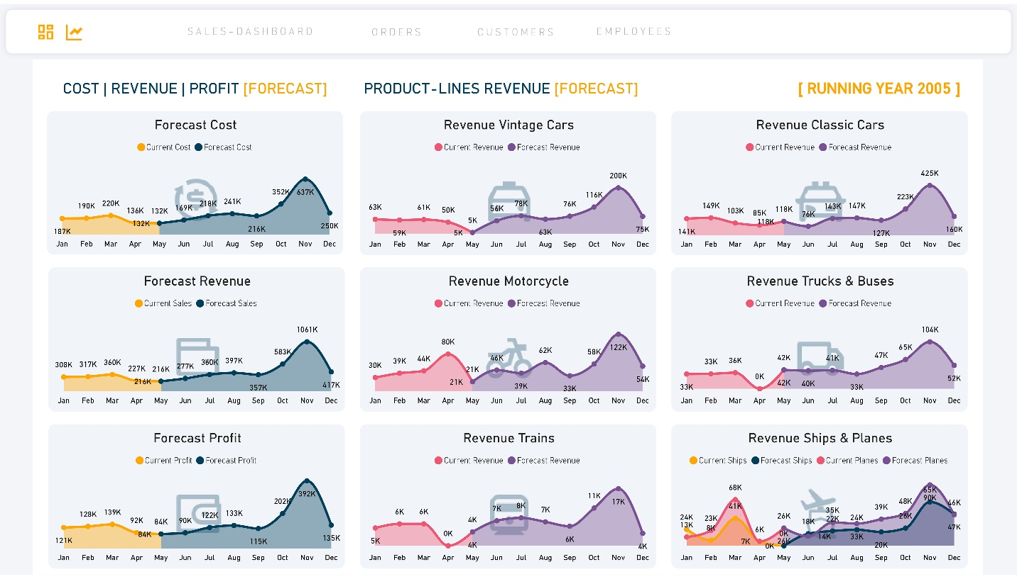

* This dashboard is helpful in checking the upcoming trends for the current running year.
* It has revenue, cost & profit wise forecast. As we previously checked that in the month November of each year, we have a highest sale and here our trend is also showing that the upcoming November month will might have a higher sale as compared to other months.
* Similarly, on the right-hand side we can also be able to see the forecast by product line wise also.
* With that trend line, we will be able to manage our stock that in which month which product line needs to be stored and how much.